《数据结构》实验报告（五）

学生姓名 李蔚
班 级 计算机2002
学 号 202801108
指导老师 陈 宏 建
成 绩

序号 | 项目名称 | 考核比重 | 得分
1 | 实验预习 | 10%
2 | 实验验收 | 60%
3 | 实验报告 | 30%

2021年 11月 24 日
实验名称： 二叉树的运算
实验时间： 2021 年 11 月 17 日 第 11 周 星期 三
一、实验预习
1、实验目的
理解二叉树的性质，懂得递归和非递归创建二叉树的方法及先序遍历、中序遍历、后序遍历、层次遍历的算法与实现。
2、实验内容（包括自己设计增加的内容等）
利用递归和非递归的方法实现二叉树的创建、先序遍历、中序遍历、后序遍历、层次遍历的算法。
（附加题：实现求二叉树深度、叶子数、结点数以及交换二叉树中所有结点的左右子树）。
二、实验报告
1、实验结果（包括程序运行结果、实测数据结果、数据分析等）
//递归
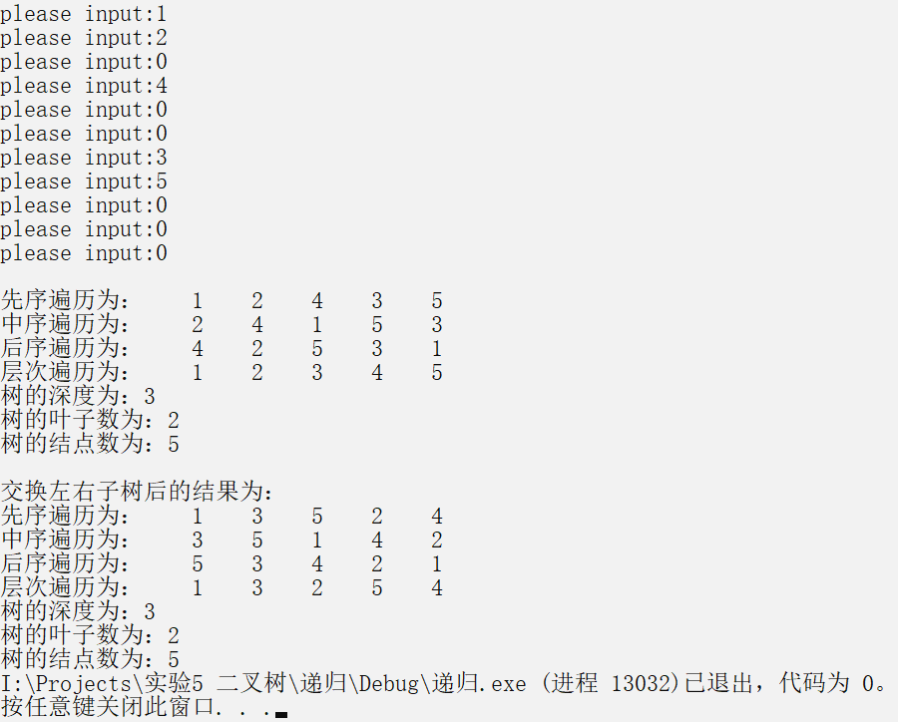
//非递归
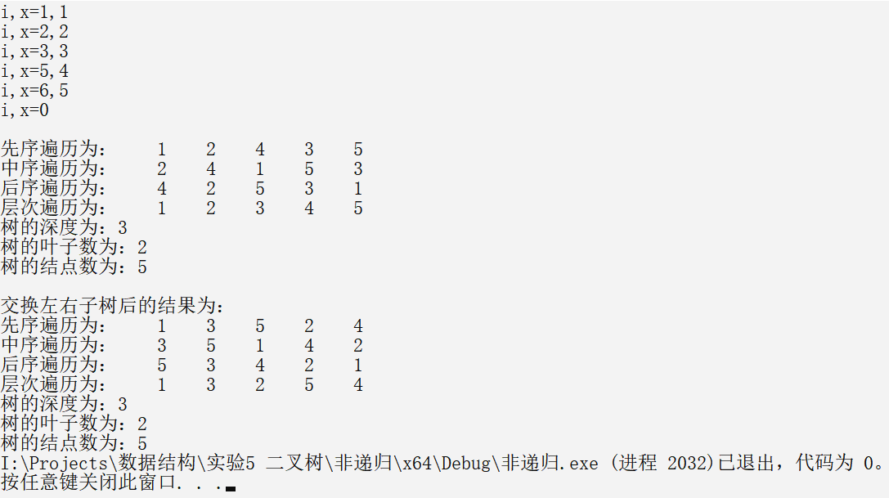
2、实验结论
验证了递归和非递归的方法实现二叉树的创建、先序遍历、中序遍历、后序遍历、层次遍历的算法，实现了求二叉树深度、叶子数、结点数以及交换二叉树中所有结点的左右子树等操作。

附录：（程序源代码）

//递归
main.c
#define _CRT_SECURE_NO_WARNINGS
#include<stdio.h>
#include<stdlib.h>
#include"def.h"
#include"bittree.h"
int main() {
bitnode* tree = NULL;
tree=create(tree);
print(tree);
printf("\n\n交换左右子树后的结果为：");
print(swap(tree));
return 0;
}
def.h
#pragma once
#define MAXSIZE 32
typedef struct bitnode {
int data;
struct bitnode* lchild, * rchild;
}bitnode;
typedef struct queue {
bitnode* data[MAXSIZE];
int front, rear;
}queue;
queue* queueinit() {
queue* q;
q = (queue*)malloc(sizeof(queue));
q->front = q->rear = 0;
return q;
}
int isempty(queue* q) {
if (q->front == q->rear)return 1;
else return 0;
}
void enqu(bitnode* data, queue* q) {
if ((q->rear + 1) % MAXSIZE == q->front) {
printf("队列满\n");
exit(0);
}
else q->data[++q->rear % MAXSIZE] = data;
}
bitnode* dequ(queue* q) {
if (q->front == q->rear) {
printf("队列空\n");
exit(0);
}
else return q->data[++q->front % MAXSIZE];
}
bittree.h
#pragma once
bitnode* create(bitnode* tree) {
int x;
printf("please input:");
scanf("%d", &x);
if (x == 0)tree = NULL;
else {
tree = (bitnode*)malloc(sizeof(bitnode));
tree->data = x;
tree->lchild = create(tree->lchild);
tree->rchild = create(tree->rchild);
}
return tree;
}
void preorder(bitnode* tree) {
if (tree != NULL) {
printf("%5d", tree->data);
preorder(tree->lchild);
preorder(tree->rchild);
}
}
void inorder(bitnode* tree) {
if (tree != NULL) {
inorder(tree->lchild);
printf("%5d", tree->data);
inorder(tree->rchild);
}
}
void lateorder(bitnode* tree) {
if (tree != NULL) {
lateorder(tree->lchild);
lateorder(tree->rchild);
printf("%5d", tree->data);
}
}
void levelorder(bitnode* tree) {
if (tree != NULL) {
queue* q = queueinit();
enqu(tree, q);
while (!isempty(q)) {
bitnode* t = dequ(q);
printf("%5d", t->data);
if (t->lchild != NULL)enqu(t->lchild,q);
if (t->rchild != NULL)enqu(t->rchild,q);
}
}
}
int depth(bitnode* tree) {
if (tree != NULL)return 1 + (depth(tree->lchild) > depth(tree->rchild) ? depth(tree->lchild) : depth(tree->rchild));
else return 0;
}
int leef(bitnode* tree) {
if (tree == NULL)return 0;
if (tree->lchild == NULL&& tree->rchild == NULL)return 1;
else return leef(tree->lchild) + leef(tree->rchild);
}
int node(bitnode* tree) {
if (tree != NULL)return 1 + node(tree->lchild) + node(tree->rchild);
else return 0;
}
bitnode* swap(bitnode* tree) {
if (tree == NULL)return tree;
if (tree->lchild != NULL || tree->rchild != NULL) {
bitnode* t = tree->lchild;
tree->lchild = tree->rchild;
tree->rchild = t;
tree->lchild = swap(tree->lchild);
tree->rchild = swap(tree->rchild);
}
return tree;
}
void print(bitnode* tree) {
printf("\n先序遍历为：");
preorder(tree);
printf("\n中序遍历为：");
inorder(tree);
printf("\n后序遍历为：");
lateorder(tree);
printf("\n层次遍历为：");
levelorder(tree);
printf("\n树的深度为：%d", depth(tree));
printf("\n树的叶子数为：%d", leef(tree));
printf("\n树的结点数为：%d", node(tree));
}

//非递归
main.c
#define _CRT_SECURE_NO_WARNINGS
#include<stdio.h>
#include<stdlib.h>
#include"def.h"
#include"bittree.h"
int main() {
bitnode* tree;
tree = (bitnode*)malloc(sizeof(bitnode));
tree = create(tree);
print(tree);
printf("\n\n交换左右子树后的结果为：");
print(swap(tree));
return 0;
}
def.h
#pragma once
#define MAXSIZE 32
typedef struct bitnode {
int data;
int flag;
struct bitnode* lchild, * rchild;
}bitnode;
typedef struct queue {
bitnode* data[MAXSIZE];
int front, rear;
}queue;
typedef struct stack {
bitnode* data[MAXSIZE];
int top;
}stack;
queue* queueinit() {
queue* q;
q = (queue*)malloc(sizeof(queue));
q->front = q->rear = 0;
return q;
}
int isemptyqueue(queue* q) {
if (q->front == q->rear)return 1;
else return 0;
}
void enqu(bitnode* data, queue* q) {
if ((q->rear + 1) % MAXSIZE == q->front) {
printf("队列满\n");
exit(0);
}
else q->data[++q->rear % MAXSIZE] = data;
}
bitnode* dequ(queue* q) {
if (q->front == q->rear) {
printf("队列空\n");
exit(0);
}
else return q->data[++q->front % MAXSIZE];
}
stack* stackinit() {
stack* s;
s = (stack*)malloc(sizeof(stack));
s->top = -1;
return s;
}
int isemptystack(stack* s) {
if (s->top == -1)return 1;
else return 0;
}
void push(bitnode* data, stack* s) {
if (s->top == MAXSIZE) {
printf("堆栈满\n");
exit(0);
}
else s->data[++s->top] = data;
}
bitnode* pop(stack* s) {
if (s->top == -1) {
printf("堆栈空\n");
exit(0);
}
else return s->data[s->top--];
}
bitnode* gettop(stack* s) {
if (s->top == -1) {
printf("堆栈空\n");
exit(0);
}
else return s->data[s->top];
}
bittree.h
#pragma once
bitnode* create(bitnode* t)
{
bitnode* s[32], * q;
int i, j, x;
printf("i,x=");
scanf("%d,%d", &i, &x);
while (i != 0){
q = (bitnode*)malloc(sizeof(bitnode));
q->data = x;
q->lchild = NULL;
q->rchild = NULL;
s[i] = q;
if (i == 1) t = q;
else {
j = i / 2;
if (i % 2 == 0) s[j]->lchild = q;
else s[j]->rchild = q;
}
printf("i,x=");
scanf("%d,%d", &i, &x);
}
return t;
}
void preorder(bitnode* t) {
stack* s = stackinit();
if (t != NULL) {
push(t, s);
printf("%5d", t->data);
t = t->lchild;
while (!isemptystack(s)||t!=NULL) {
if (t != NULL) {
push(t, s);
printf("%5d", t->data);
t = t->lchild;
}
else t = pop(s)->rchild;
}
}
}
void inorder(bitnode* t) {
stack* s = stackinit();
if (t != NULL) {
push(t, s);
t = t->lchild;
while (!isemptystack(s)||t!=NULL) {
if (t != NULL) {
push(t, s);
t = t->lchild;
}
else {
t = pop(s);
printf("%5d", t->data);
t = t->rchild;
}
}
}
}
void lateorder(bitnode* t) {
stack* s = stackinit();
if (t != NULL) {
push(t, s);
t->flag = 0;
t = t->lchild;
while (1) {
if (t != NULL) {
push(t, s);
t->flag = 0;
t = t->lchild;
}
else {
t = gettop(s);
t->flag = 1;
if (t->rchild != NULL) t = t->rchild;
else {
while (gettop(s)->flag) {
printf("%5d", pop(s)->data);
if (isemptystack(s)) return;
}
t = gettop(s);
t->flag = 1;
t = t->rchild;
}
}
}
}
}
void levelorder(bitnode* tree) {
if (tree != NULL) {
queue* q = queueinit();
enqu(tree, q);
while (!isemptyqueue(q)) {
bitnode* t = dequ(q);
printf("%5d", t->data);
if (t->lchild != NULL)enqu(t->lchild,q);
if (t->rchild != NULL)enqu(t->rchild,q);
}
}
}
int depth(bitnode* t) {
stack* s = stackinit();
int depth = 0;
if (t != NULL) {
push(t, s);
t->flag = 1;
if (t->flag > depth) depth = t->flag;
bitnode* tmp = t;
t = t->lchild;
while (!isemptystack(s) || t != NULL) {
if (t != NULL) {
push(t, s);
t->flag = tmp->flag + 1;
if (t->flag > depth) depth = t->flag;
tmp = t;
t = t->lchild;
}
else {
tmp = pop(s);
t = tmp->rchild;
}
}
}
return depth;
}
int leef(bitnode* t) {
stack* s = stackinit();
int cnt = 0;
if (t != NULL) {
push(t, s);
if(t->lchild==NULL&&t->rchild==NULL) cnt++;
t = t->lchild;
while (!isemptystack(s) || t != NULL) {
if (t != NULL) {
push(t, s);
if (t->lchild == NULL && t->rchild == NULL) cnt++;
t = t->lchild;
}
else t = pop(s)->rchild;
}
}
return cnt;
}
int node(bitnode* t) {
stack* s = stackinit();
int cnt = 0;
if (t != NULL) {
push(t, s);
cnt++;
t = t->lchild;
while (!isemptystack(s) || t != NULL) {
if (t != NULL) {
push(t, s);
cnt++;
t = t->lchild;
}
else t = pop(s)->rchild;
}
}
return cnt;
}
bitnode* swap(bitnode* tree) {
if (tree == NULL)return tree;
stack* s = stackinit();
if (tree != NULL) {
bitnode* t = tree;
push(t, s);
if (t->lchild != NULL || t->rchild != NULL) {
bitnode* tmp = t->lchild;
t->lchild = t->rchild;
t->rchild = tmp;
}
t = t->lchild;
while (!isemptystack(s) || t != NULL) {
if (t != NULL) {
push(t, s);
if (t->lchild != NULL || t->rchild != NULL) {
bitnode* tmp = t->lchild;
t->lchild = t->rchild;
t->rchild = tmp;
}
t = t->lchild;
}
else t = pop(s)->rchild;
}
}
return tree;
}
void print(bitnode* tree) {
printf("\n先序遍历为：");
preorder(tree);
printf("\n中序遍历为：");
inorder(tree);
printf("\n后序遍历为：");
lateorder(tree);
printf("\n层次遍历为：");
levelorder(tree);
printf("\n树的深度为：%d", depth(tree));
printf("\n树的叶子数为：%d", leef(tree));
printf("\n树的结点数为：%d", node(tree));
}

